**Development Assignment 3 – Adit Kulkarni**

**Web Technologies**

**MSIS517L**

Screenshots of Database Table of Contents, User re-directed to page where message of success id displayed and screenshot of email received.

Screenshot of Database records –

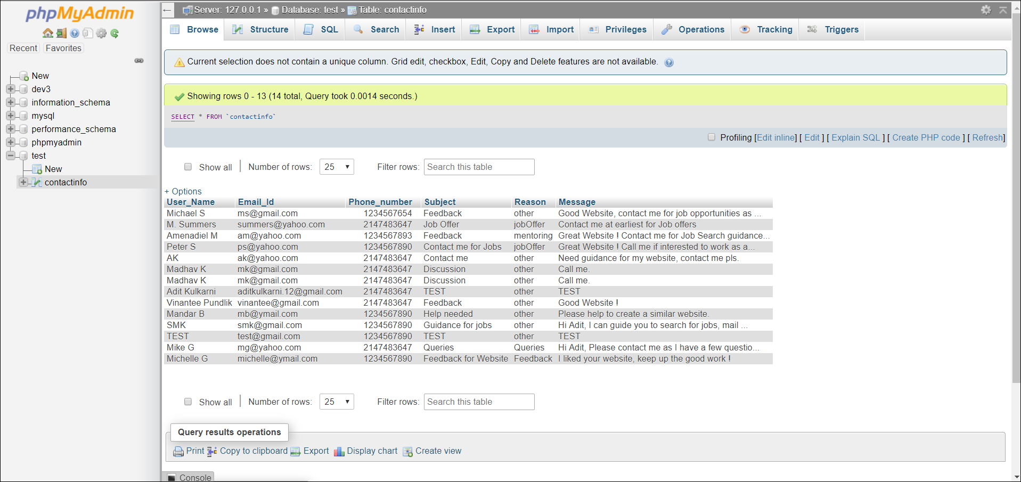

Screenshot of Email received –

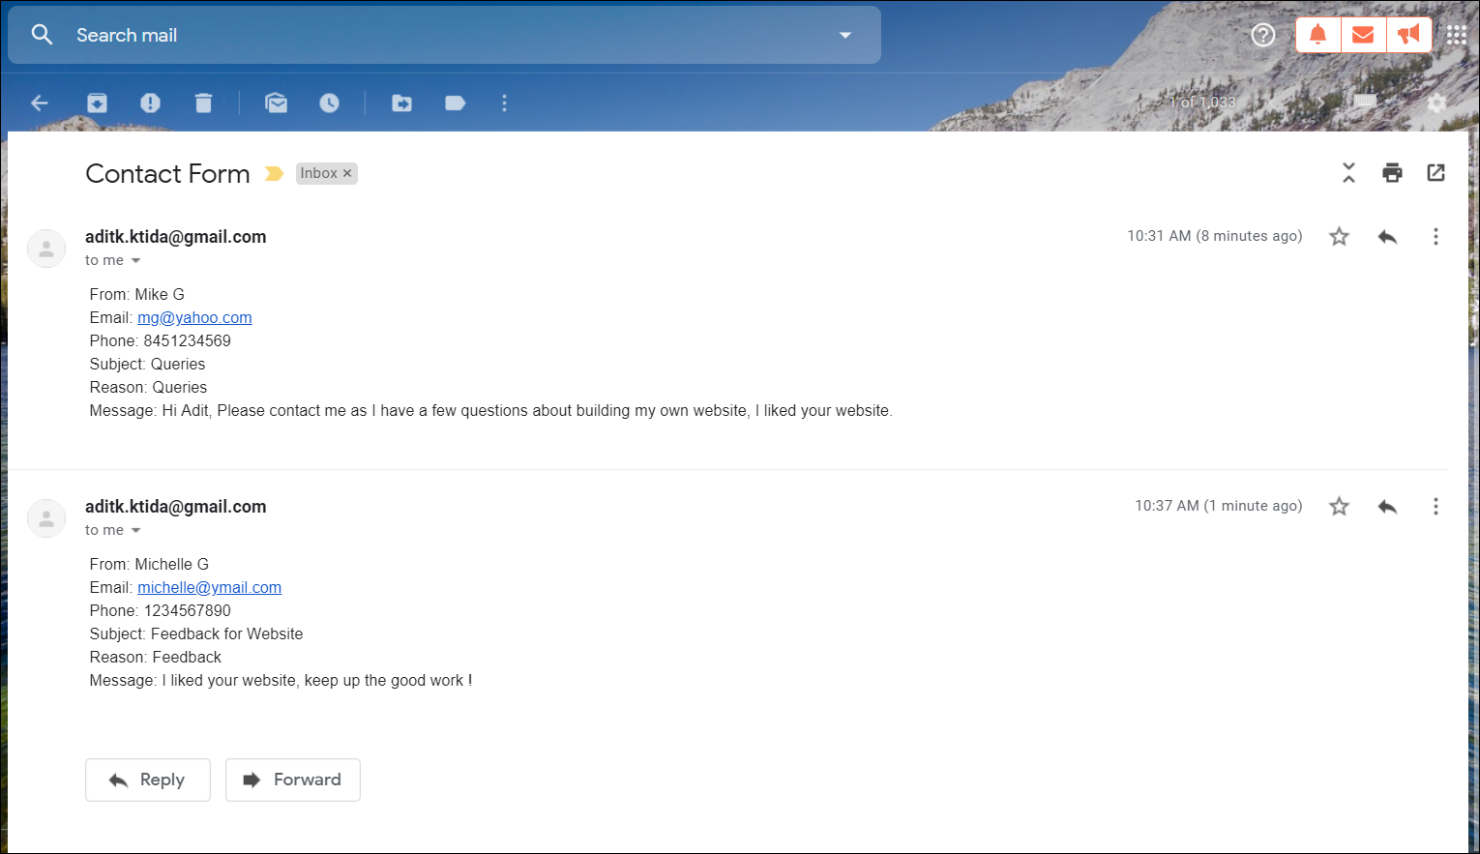

Details uploaded successfully message page –

